Support Vector Machine

Support Vector Machine (SVM) is a supervised binary classification machine learning algorithm widely used in classification, regression, decision tasks, feature selection and feature extraction. It is a discriminative decision machine intended to find the discriminant function that accurately predicts the labels for newly required instances in context of independent and identically distributed training dataset. Main advantage of SVM leads to the fewer computational resource requirement, less training data especially for a multidimensional feature space, when posterior probabilities are needed. Now let’s see, how SVM works.

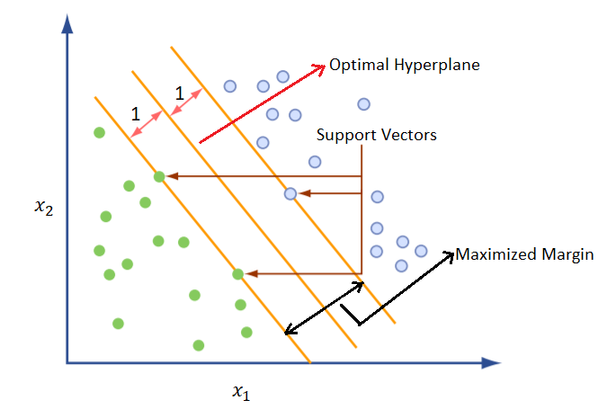

Basic principle of SVM is to create the hyperplane that separates the data into classes.

There are two main criteria taken into consideration.

1. Finding a hyperplane

To choose the best plausible hyperplane that eliminates the optimization problem, we have to consider the specific set of points called difficult points close to decision boundary. Lagrange Multipliers technique is used to convert the problem in such a way that it can be solved analytically.

Support Vectors : Input vectors that just touch the boundary of the margin (street) ,shown by circle.

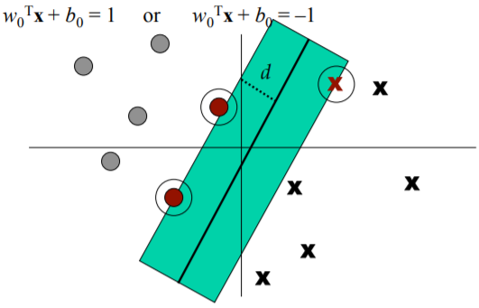

Hyperplanes can be defined by following equations.

2. Maximizing the margin.

Linear separator with a big margin is used here.

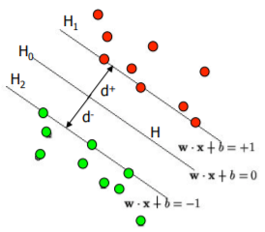

The total distance between H1 and H2 is thus: $2/\left\|w\right\|$.

In order to maximize the margin, we need to minimize $\left\|w\right\|$. With the condition mentioned in eq. 1 & 2 there are no data points between H1 and H2 Eq. 1 & 2 can be combined into $y_{i}\left(x_{i}∙w\right)≥1$.